
How to Download and Install Chime:
- Navigate to https://chime.aws/trial/ and click the DOWNLOAD button below the operating system of your choice.
  - Please note:
    - Chime for Android supports voice only (no video available yet)
    - Don’t be alarmed by the “14-Day Trial for New Customers” verbiage. This does not apply to you as the meeting is being hosted by Amazon.
- Click Save to save the file to your Downloads folder.
- Navigate to your Downloads folder and open the downloaded file. The next steps may differ, depending on your operating system:
  - Windows Users:
    - Navigate to your Start menu, and select Computer. Locate and select the Downloads folder
    - Double-click on the Chime.exe software file
    - In the pop-up window, click Run and the Installer should launch ▪ Follow the Installer prompts and click Install.
    - Once the Installer has completed, click Finish
    - To launch Chime, navigate to your Start menu, type “Chime” into the search box, and double-click on the Amazon Chime icon when it shows up
  - Mac Users:
      - From your Downloads folder, double-click on the Chime.dmg software file
      - In the new window, drag and drop the Chime icon into the Applications folder ▪ Double-click on the Applications folder and navigate to “Chime” in the list.
      - Double-click to launch the program
      - If you encounter a message saying “Chime can’t be opened because the identity of the developer cannot be confirmed,” click “OK” and follow the steps below:
      - Navigate the following path: Apple icon (top left) > System Preferences > Security & Privacy
      - Under the General tab, you can select “Anywhere” under the “Allow apps downloaded from:” section. At this point you will be able to open Chime.
      - You may also be presented with an option to “Open Anyway,” so you don’t have to change your download preferences.

How to Use Chime:
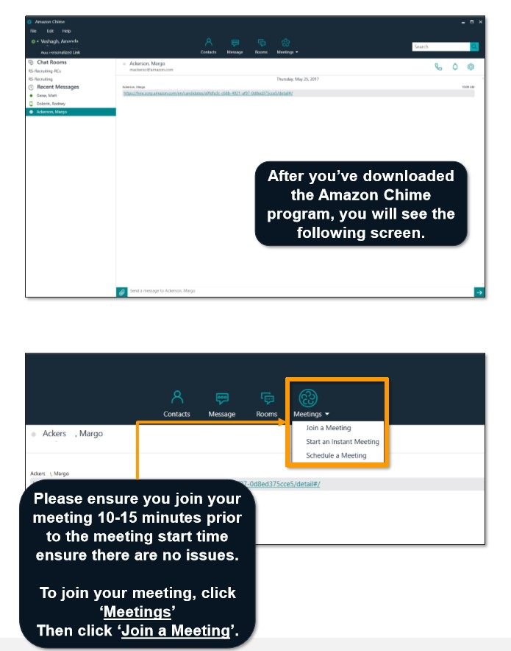
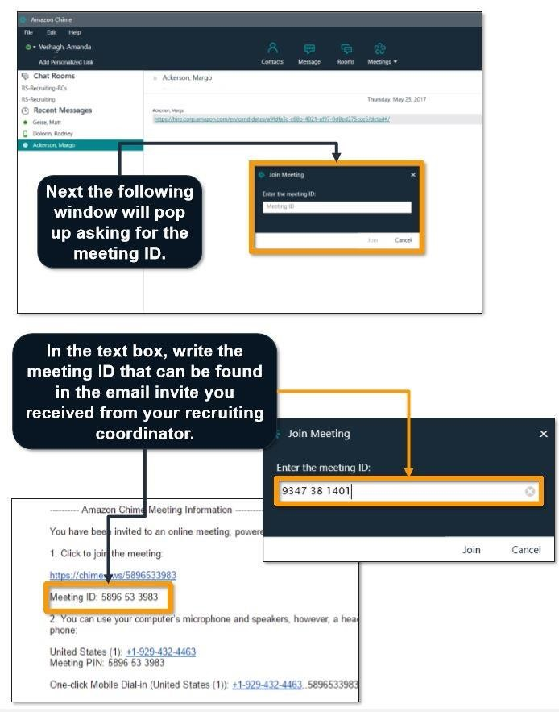

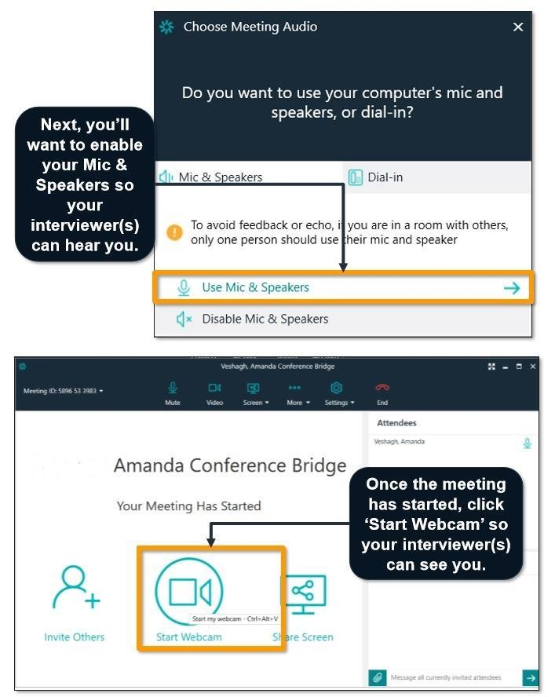
Questions? Please visit the Amazon Chime Answers Center at: https://answers.chime.aws/

